Case study

By-:Saurabh Singh

(RA1911005010023)

TITLE:- Making a logo detection website using UI/UX.

Executive Summary-➡️

The logo search feature aims to solve the difficulty in finding and registering trademarks for logos. The goal is to provide users with a simple and intuitive platform where they can upload their logos, find similar logos, and file trademarks for their logos. The purpose of the logo search feature is to allow users to search for similar "logo trademarks", to effectively find out if your logo is registrable or not. Come up with appropriate CTAs for conversions/lead generation.

Background-➡️

To make Logo detection website I use Figma software where I make many pages like -👍

1.Landing page-👍

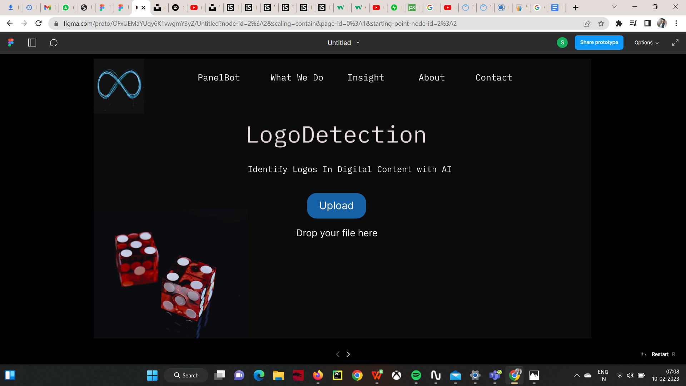

2. Upload pages-👍

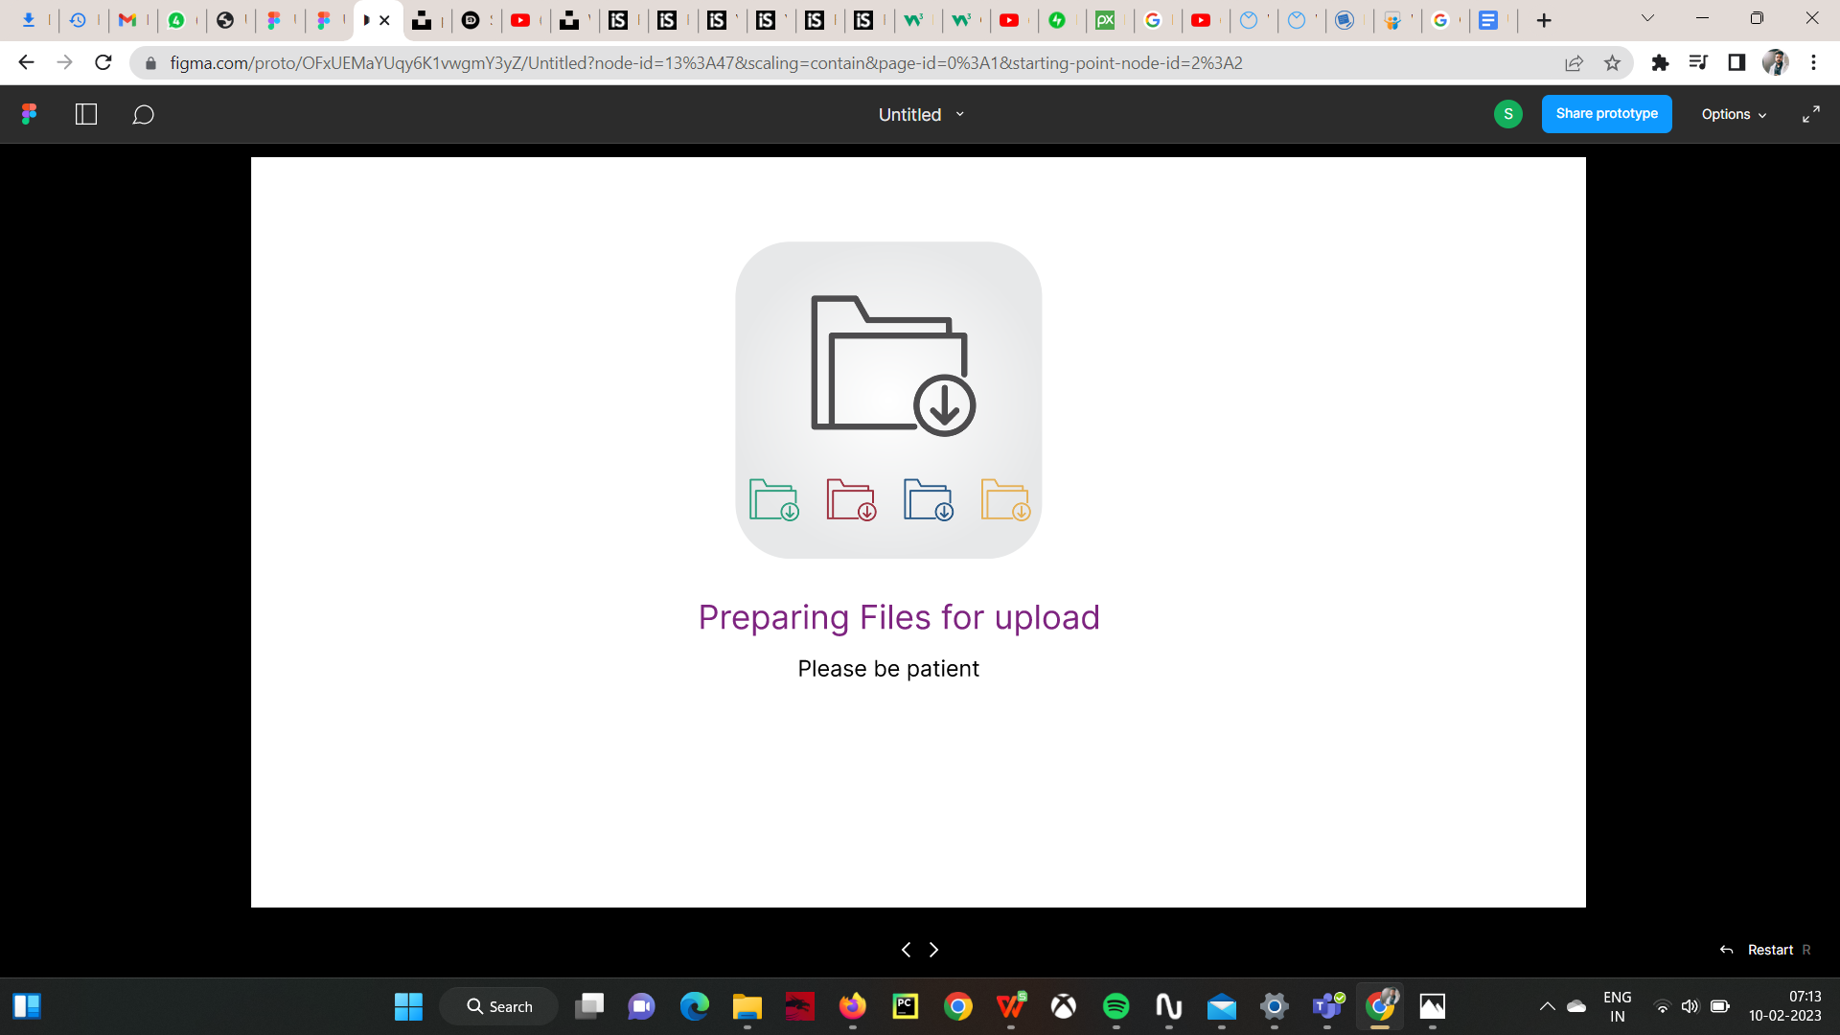

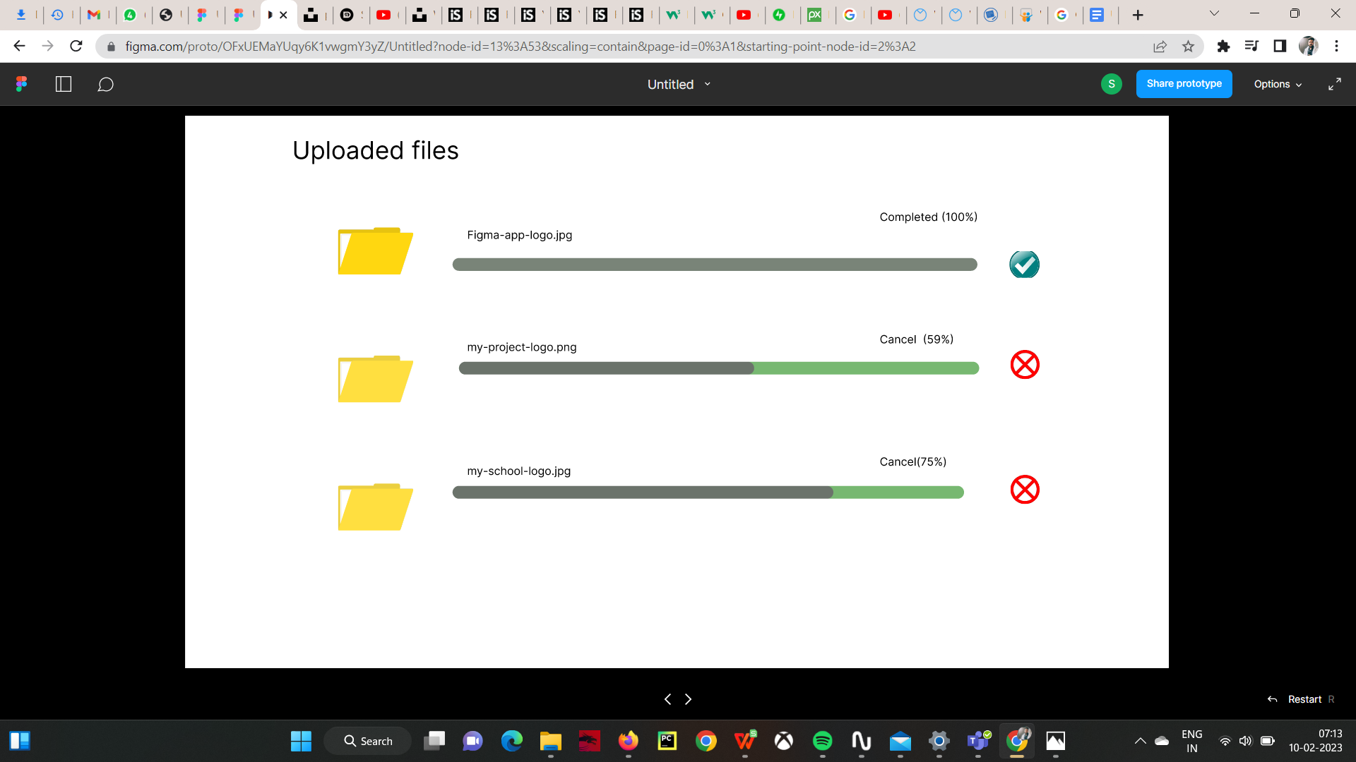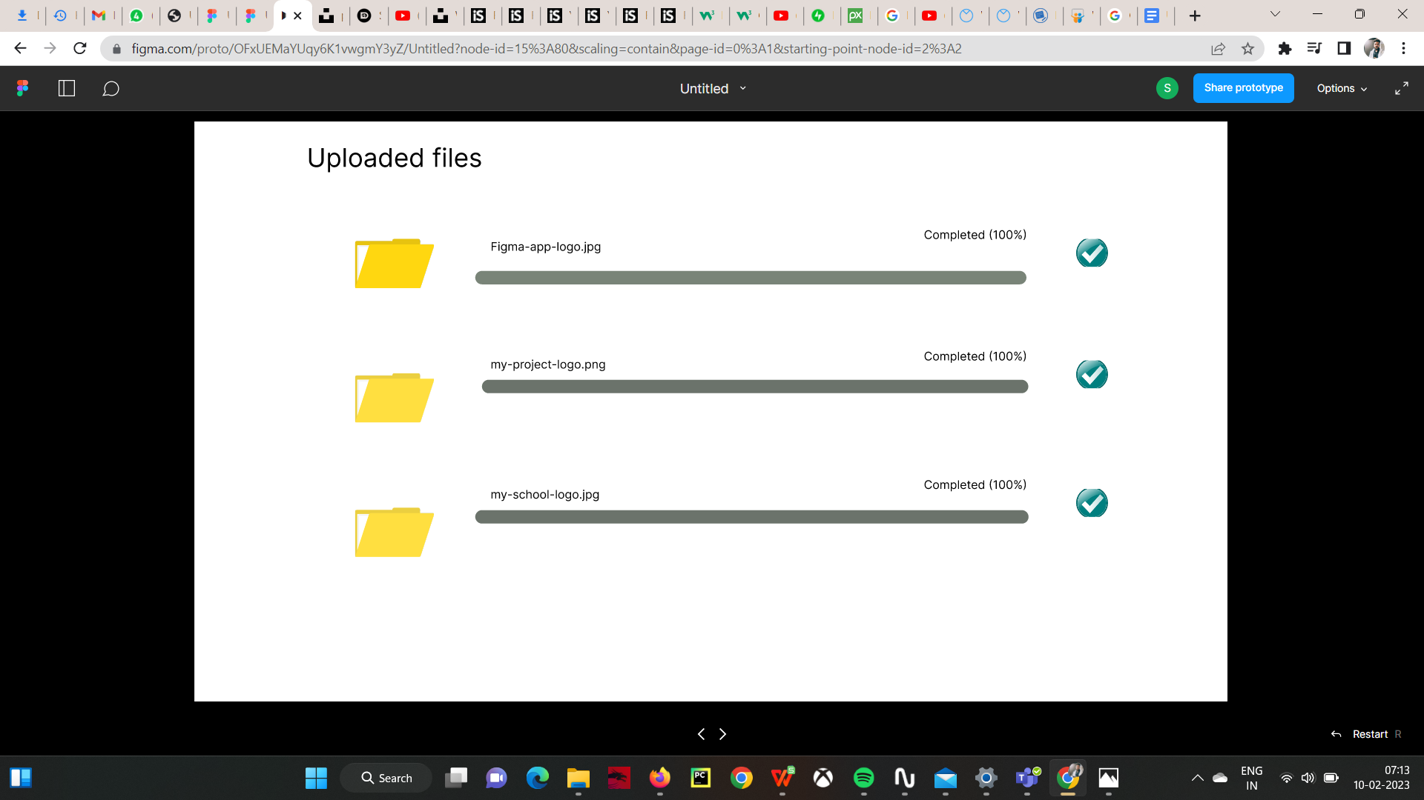

Working flow-👍

Basically My project asks to upload the logo image file to the user and After the uploading files our AI detects the file is using before or not If It is not used yet then it will tell that this is registrable. If someone uses it before then it will show “please try again”.



Deliverables-👍

1.Figma design

2. Case study Document

Visual Design-👍

Design UI in Figma

1.Landing page

2. Upload pages

3. Result page once user upload a logo.

Conclusion-👍

In conclusion, I will show some images for this project.

Result page 1.



Result Page 2-👍

